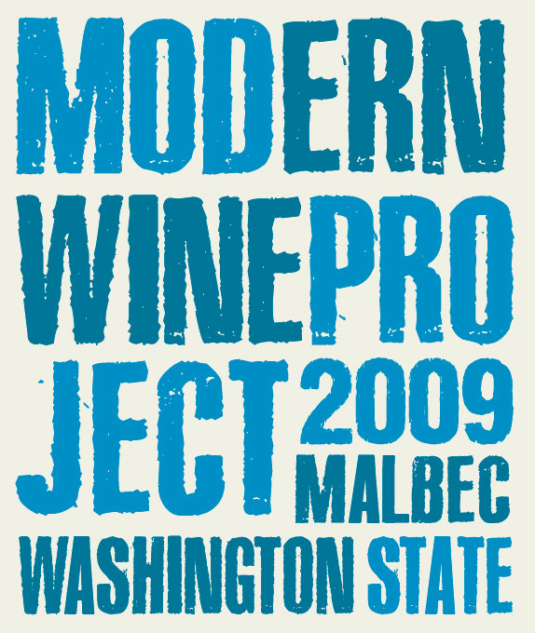

**2009 Modern Wine Project Malbec**

84% Malbec, 8% Merlot, 5% Cabernet Sauvignon, 3% Petit Verdot

From the warm 2009 vintage in Washington State comes the “newest” Malbec from the Modern Wine Project, a side label of the cult winery, Sleight of Hand Cellars, in Walla Walla, WA. You would expect to pay twice the price for what is in the bottle. This Malbec was aged in mostly new French oak for 30 months, and has been in bottle for the last year, undisturbed and waiting for this release date! Dark and rich, this Malbec is NOT Argentina. It has its own Washington State personality, full bodied yet vibrant, and a beautiful core of red and black fruits. It has a wonderfully full, silky texture from the extended barrel aging and long, spicy finish. Meant to share and impress, we hope you buy several for your next dinner party!